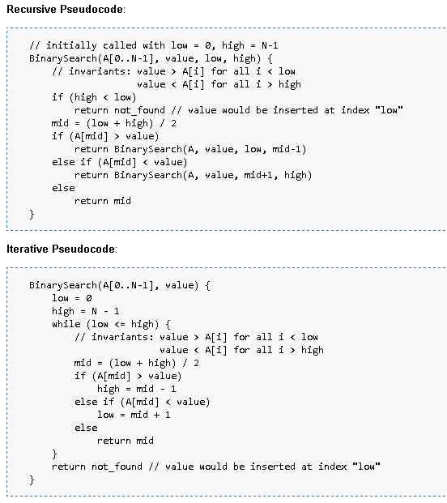

Note: If you want you can discuss with your course mate.